Peterloo and Mount Street Quaker Meeting House

Elizabeth Bailey
February 2019

Peterloo and Mount Street Quaker Meeting House
For a good number of years, the panel in the Quaker Tapestry, that depicts Mount Street and the part it played at Peterloo, has been accepted as a true record – Friends in the Meeting House giving refuge to and tending some of the casualties of the mayhem outside.

Peterloo Massacre 1819. Cotton Workers ridden down by Militia at a Meeting for Parliamentary Reform are given refuge in the Friends’ Meeting House in Manchester

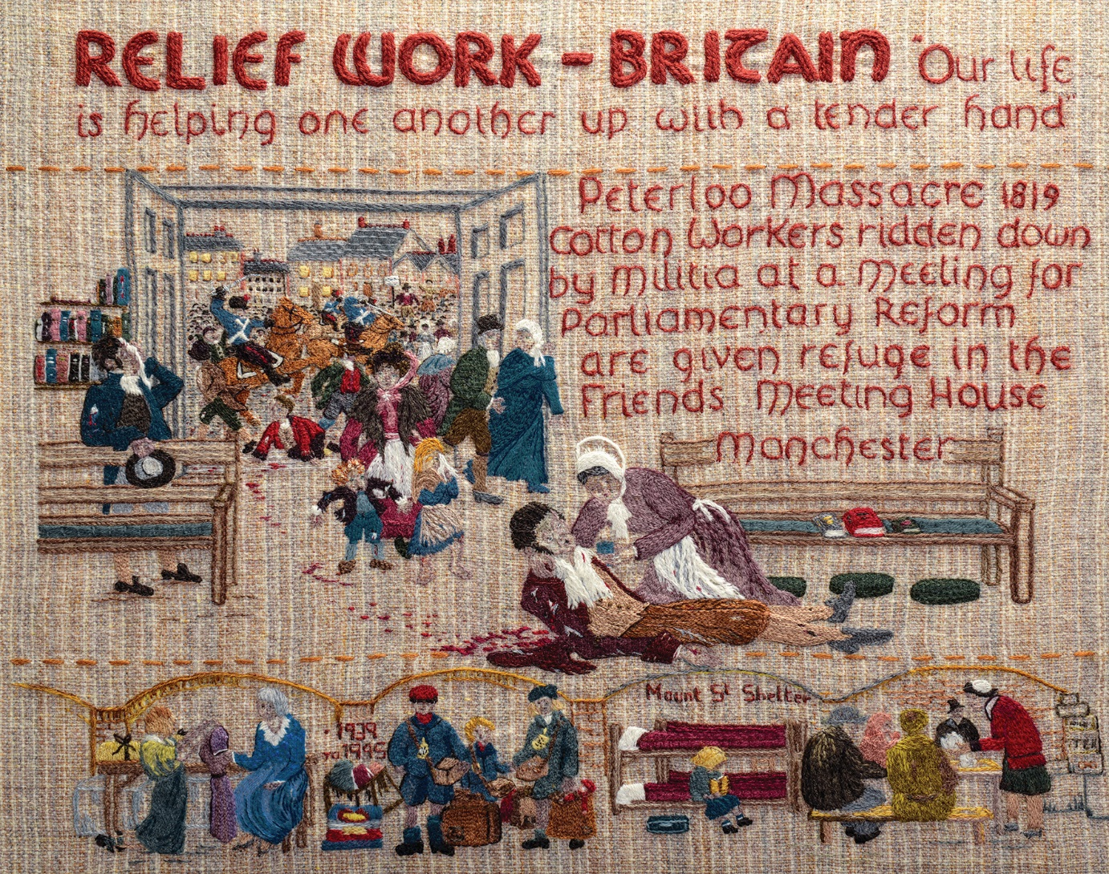

Quaker Tapestry ©
77 panels known as the Quaker Tapestry is a modern community embroidery made by 4,000 people from 15 countries. The exhibition of panels can be seen at the Quaker Tapestry Museum in the Friends Meeting House in Kendal, Cumbria UK
Further information: http://www.quaker-tapestry.co.uk

A closer study of contemporary accounts and records calls the panel’s depiction of this incident into question.

Some Background
The Meeting House was, at that time, facing Deansgate.
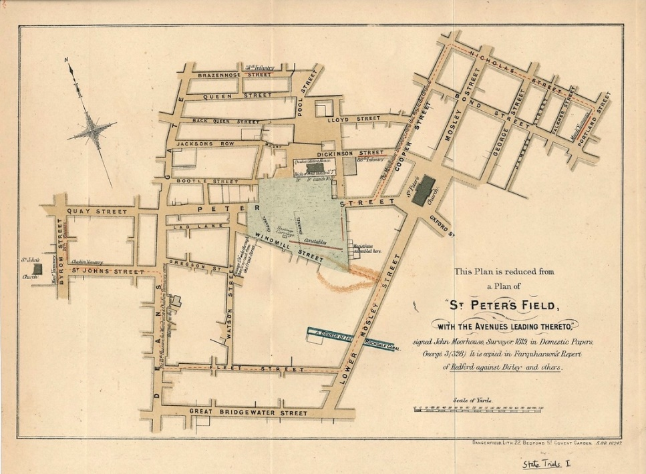
Peterloo Plan from State Trials, 1820
D. A. Bruton, Three Accounts of Peterloo (1919), 89-90
Mount Street Meeting House

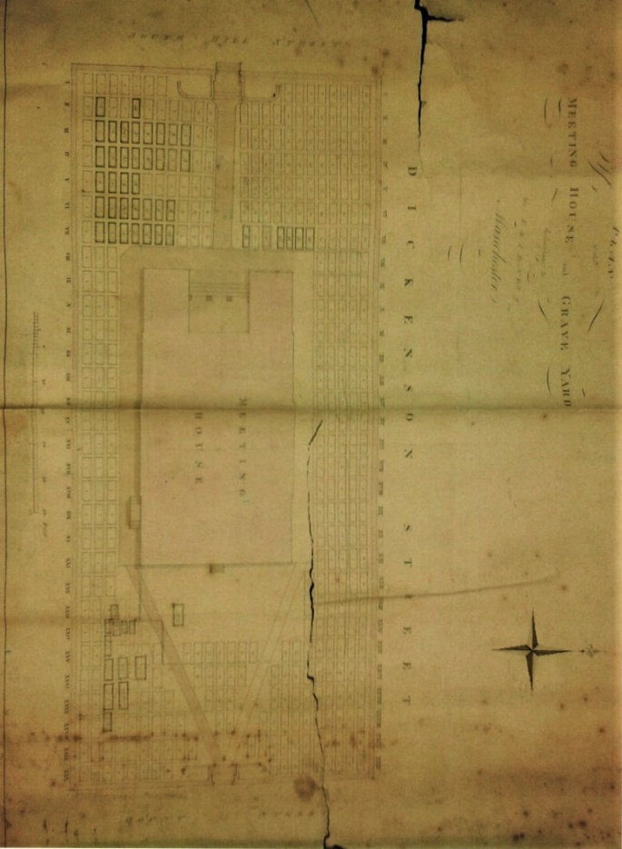
Plan of Meeting House and Burial Ground c 1795
M85/50 MANCHESTER PREPARATIVE MEETING
Manchester Archives and Local Studies

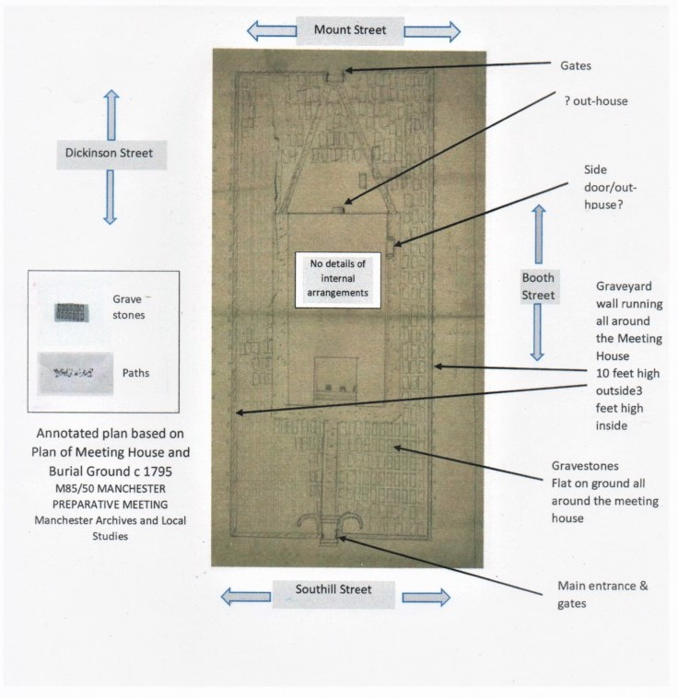
There are no extant drawings of the Meeting House, to our knowledge. A contemporary illustration shows, on its far left-hand side, the wall of the Quaker School. The Meeting House would be to the left of this.
Peterloo Scene 1819. Annals of Manchester London: ref 942.73 C5

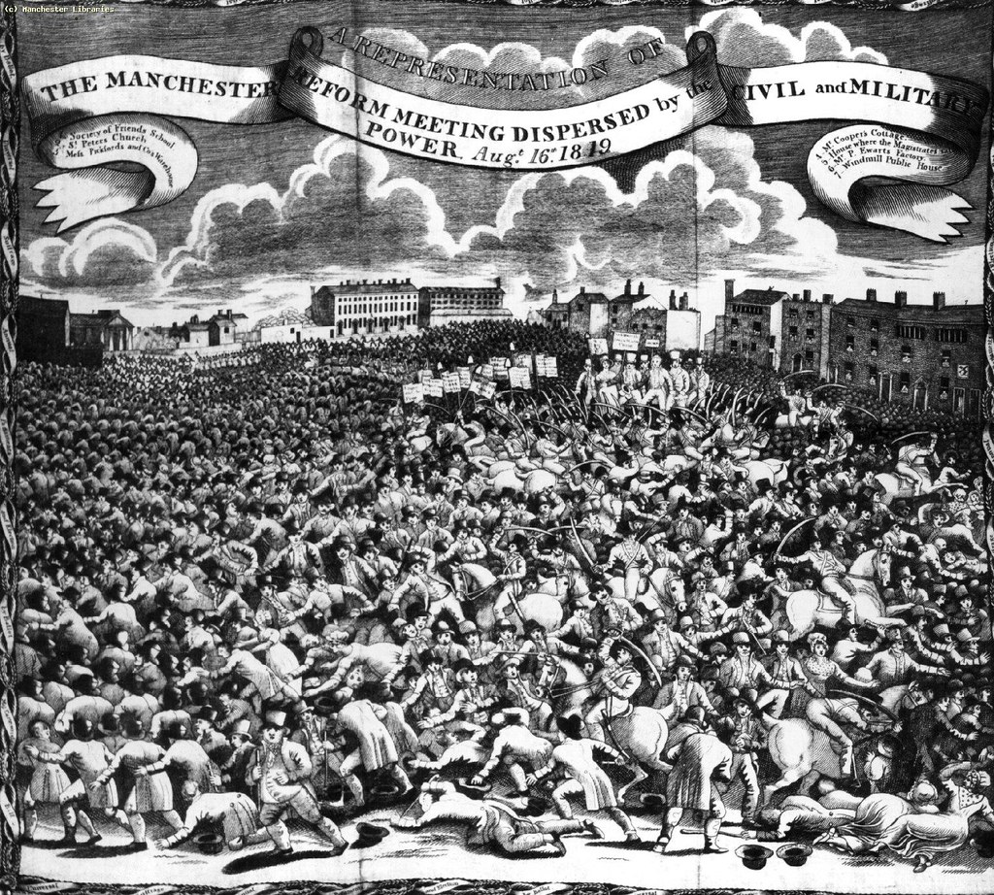
Wall of Quaker School

Contemporary non–Quaker Material
It is quite clear from various newspaper reports that there was much activity around the Meeting House, particularly under the walls and inside the grounds. Two examples:
Near the Quaker’s Meeting-house a furious battle raged. In the burying ground many persons committed murderous work from the enclosed walls, till the gates were burst open by a private soldier, with the butt end of his musket. Many innocent spectators had also been there, during the whole of the day, as a place of security. At length it was, necessarily, cleared by force.
The Morning Post. London. 25 August, 1819.

The foot troops were marched to a station at the south end of the Quaker’s Meeting-house, to intercept the people who might fly in that direction; and here there was indeed most dreadful slaughter. Crowds pressed onto this quarter and were forced back by the bayonets of the infantry, the cavalry cutting them in the rear. The shouts, screams and confusion, were here truly terrible. The people, maddened with the danger, seemed under the influence of supernatural energy; they scaled the walls of the meeting house yard in every direction, while those near the yard gates burst them open; the soldiers followed up the steps into the yard, and cut away without any seeming compunction. The Meeting House doors were then, in the terror of the people, also forced; but even a Quaker place of worship was no sanctuary – the soldiers still followed and many wounds were given here; - even in the galleries, which is difficult of access, there were many, many stains of blood. For several days afterward, workmen had to be employed to plane away, and otherwise obliterate the evidence left here of the butchering which had taken place.
‘Provincial Intelligence’, Sunday, September 12, 1819, The Examiner, Issue 611.

Slightly later, eyewitness accounts offer more information. Two examples:
William Norris Buckley’s evidence:
Q. Where were you when the Cavalry charged?
A. In the Quakers' Meeting-House yard, as I said before.
Q. Where were you at the time of the dispersion?
A . As I was passing the Quakers’ yard, a thought struck me that I should be safe there, and I climbed over the wall, where I had an opportunity of witnessing the proceedings. I saw women, with children in their arms; many lying on the ground, with others assisting. I did not chuse to run any risque, as the carnage seemed to be indiscriminate.
Q. Did you, shortly after the 16th, examine the Quakers' burying-ground?
A. Yes, I did within three or four days after.
Q. Did you observe any thing particular as to the trees in the Chapel-yard?
A. Yes, I saw several of the branches had been cut off; and there were evidently sabre cuts on the trunks.
Q. Did you make any observation respecting the rails?
A. Yes, I saw marks of blood upon the rails, or, at least, some thing that had the appearance of coagulated blood.
J. Dowling, Report on The Whole Proceedings before the Coroner’s Inquest on the body of John Lees. September 1819. London: Hone, 2005, p. 96.

‘Slater James, Chestergate, Stockport; cut in the chin. A respectable man, a book-keeper. Was in the chapel yard attempting to get into a small outhouse. Found it full. Four of the cavalry chased him round the trees and cut his hat to tatters. 20s. final.
Peterloo Relief Fund Account Book (c.1820), Rylands English MS 172.

Twenty-five years later, more details are being offered:

The mob had taken possession of various buildings on that side, particularly of a Quakers’ chapel and burial ground enclosed with a wall. This they occupied for some little time, and in attempting to displace them, some of the men and horses were struck with stones and brickbats. I was on the left, and as soon as I had passed completely over the ground and found myself in the street on the other side, I turned back, and then, seeing a sort of fight still going on the right, I went in that direction. At the very moment I reached the Quakers’ meeting-house, I saw a farrier of the 15th ride at a small door in the outer wall, and to my surprise his horse struck it with such force that it flew open. Two or three Hussars then rode in, and the place was immediately in their possession’
William J. H. Jolliffe. The Charge of the 15th Hussars at Peterloo
A letter dated 11th April 1845, which appears in G. Pellew, The Life and Correspondence of the Right Honourable Henry Addington First Viscount Sidmouth. London: Murray, 1847, p. 252.
There are more accounts in similar vein, with discrepancies and inconsistencies that reflect the sympathies of the witnesses. Nevertheless, they all describe numbers of people and military in the Meeting House and the burial yard, with significant casualties and a little damage done to the Meeting House and grounds.

Contemporary Quaker Material
The Quaker custom of good record keeping should have thrown some light on the events. However, to this date, no reference has been found to Peterloo.
One hundred years ago, a local historian of Manchester Grammar School wrote:
I have to thank the authorities who have charge of the archives at the Friends' Meeting-House for their courtesy in acceding to my request that the Records and Minute Books for August 1819 should be examined. They could find no mention whatever of Peterloo.
F. A. Bruton, The Story of Peterloo. Manchester: Manchester University Press, 1919, p. 39.
Over the last few years, members of Manchester and Warrington Area Meeting Documents and Manuscript Committee have trawled Quaker archives, including 10 years of the various Hardshaw Area Meeting and Preparative Meeting minutes and records, in search of contemporary references to the events of Peterloo. None have been found. There is no mention of the incident happening at all.
Other Quaker Material
The earliest formal Quaker reference to Peterloo found in the archives is in the handwritten account of William Brockbank:
During the Peterloo Massacre, many of the mob took refuge in this Meeting House, and more pursued into it by the soldiery – the trees in the grave yard being hacked by their swords – the green palings being splattered with blood, and the floor of the Meeting House being stained in many places.
W. Brockbank, MS in Early History of Manchester Preparative Meeting of Friends 1856.
(The Local Meeting Accounts for 1819-1821 were even examined for cleaning and carpentry bills. None were found.)
The next archived account is part of James Fellows’ recollections in 1883, which appear in Thomas Tonge’s Reminiscences of Friends in Manchester by his father-in-law, James Fellows, of Ashton-upon- Mersey, near Manchester.
My earliest recollections are of the Meeting House in South Street, which was built in 1792, the old Meeting House in Jackson's Row being converted into a school, at which the children of most of the Friends of the period were educated. It was conducted by John Taylor, the father of John Edward Taylor, the founder and first editor of the Manchester Guardian. On the occasion of the disturbance at Peterloo in 1819, many of the people took refuge from the yeomanry in the old Meeting House in South Street, and the blood from the wounds of some stained the floor for a long time, notwithstanding efforts to eradicate the marks.
J. Fellows, ‘Thomas Tonge’s Reminiscences of Friends in Manchester’, The Manchester Examiner 1883.
Both accounts speak of people taking refuge in the building. Neither mention any Quaker presence there.
The assumption that Friends were in the building seems to be based on the following: In Mount Street 1830-1930, a book produced for the centenary of the ‘new’ meeting-house, one of the chapters is headed ‘The Society of Friends in Manchester’ by Elfrida Vipont Foulds and A. Neave Brayshaw:
The meeting house entered into history on August 16th, 1819, for it served as a refuge for fugitive men, women and children, swept before the yeomanry at Peterloo. For many months afterwards its floor was stained with the marks of human blood.
Mount Street 1830-1930: an account of the society of friends in Manchester together with short essays on Quaker Life and Thought written for the Centenary of the Friends' Meeting House, Mount Street. Manchester: Mount Street, 1930, p.12.
The chapter is completely unreferenced. If the authors were using what was available in the Quaker archives, Brockbank and Tonge’s accounts would be the only ones available. Elfrida Vipont also wrote ‘Lift Up Your Lamps – The Pageant of a Friends Meeting’. In the Introduction to the first published copy in 1938, she states ‘This pageant has already been performed twice by the children of Mount Street Meeting, Manchester’. In the fourth episode, called ‘The Battle of Peterloo 1819’, two fictional Quakers, William and Sarah, are in the Meeting House, tending the wounds of five ‘fugitives’, who made ‘a right mess of your Meeting House an’ all; look at the bloodstains on the floor’.
E. Vipont, Lift Up Your Lamps. Manchester: The Manchester 1930 Committee of the Society of Friends.
Again, there are no references other than to the above chapter in the centenary book.
Reasons for the probable lack of a Quaker presence
It seems unlikely that Quakers would have been in the building for the following reasons:
- The eyewitness accounts refer to doors and gates being broken down or forced open. There is no record of them being opened up from inside.
- Would Friends have been in the centre of town, as the authorities advised people to keep away and those with shops and businesses to close for the day? Significant numbers of Mount Street Friends were tradespeople.
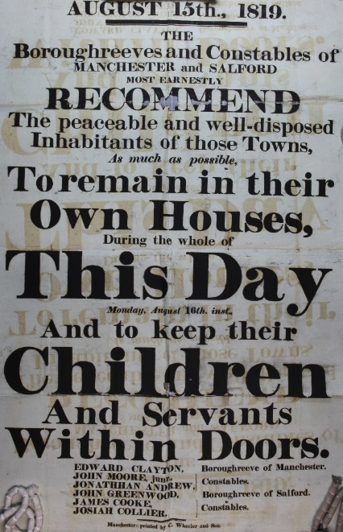
National Archives
Catalogue reference HO 42/192 f323)

More importantly, very few Friends were political reformers or radicals. Any attempt by Quakers to alter the actual framework of society was discouraged, an attitude shared by most religious bodies at that time. The corporate outlook expressed in annual epistles, in this age of reform, was one of non-involvement. The emphasis was on social and educational concerns.

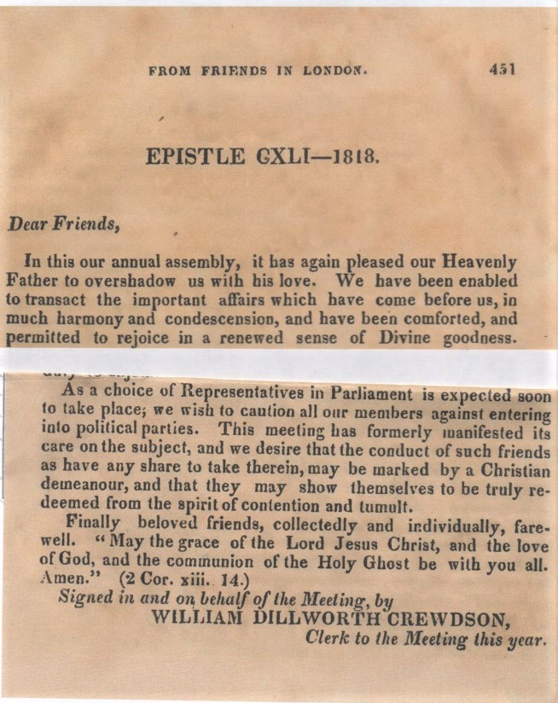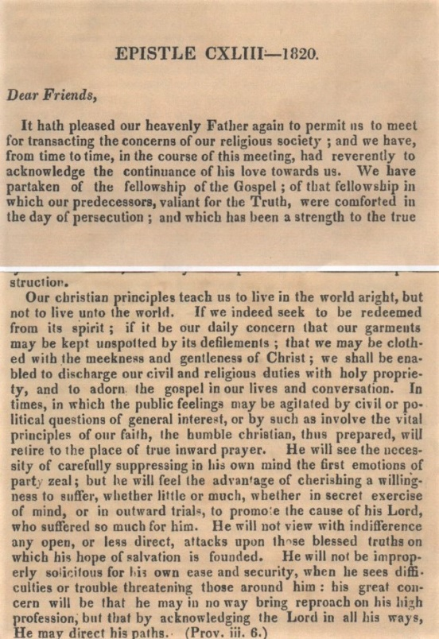
London Yearly Meeting. Epistles Collections. 1820. Copy No: 28339

London Yearly Meeting. Epistles Collections. 1818 Copy no: 6882

Any who took part in active politics tended to incur the displeasure of the Society of Friends. One Oldham Friend was, indeed, disowned for a time. John Earnshaw was a known reformer in his home town. He was actually at Peterloo, with two of the few reformers who worshipped at Mount Street, Robert Wood and a Mr Bancroft. They witnessed events from a house on Windmill Street, behind the hustings.
E. Bailey, John Earnshaw of Oldham Quaker, Surgeon, Reformer. 2018, p. 7.

Another Friend from Leigh was censured.
‘It having been stated in several of the newspapers that one Bamber, a Quaker, presided at a public meeting of those who style themselves Reformers, held at Leigh on the 11th instant, we have authority stating, that should any of the members of the Society of Friends promote proceedings tending to disturb the public peace, their conduct would have the decided disapprobation of the Society, as it is, and always has been, the desire of the Society, that its members should live quiet in the land, promoting peace, and having nothing but good will to all men.’
The Times Thursday Aug 26. 1819: Issue 10708, p.3.

Given this corporate attitude, how many other Friends, even though a number of them lived nearby in Mosley Street, would have attended the political meeting or indeed, be on ‘standby’ in the Meeting House? The attitude of Manchester Quakers to political reform in particular, which they shared with other denominations in the city, is underlined by their actions after the event.

The Roman Catholic Church in Manchester after Peterloo adopted a similar policy to that of the Anglicans and Wesleyans. On the 30th November 1819, the Manchester Mercury reported that ‘all association with the Radical Reformers was forbidden from the pulpit on pain of excommunication. …… In a similar manner the society of Quakers in Manchester also chose a policy of ‘loyalty’ after Peterloo’
Manchester Mercury, 30th November 1819.

. This ‘loyalty’ to the authorities was demonstrated by the fact that it was noted that ‘well known ’Quakers (such as John Dalton and Peter Ewart) were absent from the petition of protest against ‘the unexpected and unnecessary violence by which the assembly were dispersed’. Petition declaring support for the victims of the Peterloo Massacre and the protestors (1820) British Library RB. 23.b.4235(2).
Another Mount Street Friend demonstrated a more extreme attitude towards the reformers and was more intimately involved with the aftermath. John Ransome, ‘the surgeon, a very eminent one, a Quaker’ who was on duty at Manchester Infirmary, told one of the magistrates, W R Hay, ‘that the Cavalry must have studied to do as little mischief as they could for the wounds were so slight’.
W. R. Hay, Letter copy in Hay’s hand, Charles Worsley to the Globe, Lancaster, 3 Sept 1819, ‘copied from the Wakefield Paper 10th Sept 1819’. JRL English MS 1197.45.
This opinion is totally at variance with the contemporary evidence of death and injuries collected and recently examined and re-evaluated by Michael L. Bush in The Casualties of Peterloo. Lancaster: Carnegie Publishing, 2005.

John Ransome’s stance is more critically apparent in his treatment of some of the casualties. James Lees, suffering two severe sabre wounds to his head, was taken to the Infirmary and dressed by one of the junior doctors, who arranged for him to be admitted. Dr Ransome ‘asked him if he had enough of Manchester meetings. On his reply in the negative, he was told there was no room for him’.
M.. Bush The Casualties of Peterloo, p. 120. Taken from Peterloo Relief List: Rylands English MS.172.

This behaviour is in marked contrast to that of another Quaker doctor, John Earnshaw, mentioned previously. Not only did he witness the events on Peter’s Field (later, testifying to the peaceful nature of the demonstration), he tended some forty-two casualties, albeit in his surgery at Mumps, in Oldham and in cottages in the surrounding area. E. Bailey John Earnshaw, pp.7 & 9.

Conclusion
To describe more accurately what happened in the Meeting House on that day, perhaps the text on the tapestry panel should be amended to ‘Mill workers, ridden down by militia, at a meeting for parliamentary reform, sought refuge in the Friends’ Meeting House’.
Elizabeth Bailey
July 2019

